CLO 5 Lab 3: Flutter: Widgets, Scaffold, Assets, Images, Containers, Row Column,
Introduction
In Flutter everything is built on Widgets. UI elements, styles, themes, and even state is managed in specific Widgets.
Concept Map
Widgets
Scaffold
Assets
Images
Containers
Rows & Columns Layout
Lab Exercise
Activity Time boxing
Table 1: Activity Time Boxing

Task No. | Activity Name | Activity time | Total Time
1 | Widgets | 10 mins
2. | Scaffold | 10 mins
3. | Assets | 10 mins
4. | Images | 10 mins
5. | Containers | 10 mins
6. | Rows & Columns Layout | 10 mins
7. | Lab Exercise | 120 minutes | 180 minutes

Objective
Students learn about basic elements of Flutter application.
Students make a basic application using widgets.
Widget Build Visualization
In Flutter, widgets can be grouped into multiple categories based on their features, as listed
below −
Platform specific widgets
Layout widgets
State maintenance widgets
Platform independent / basic widgets
Platform specific widgets
Flutter has widgets specific to a particular platform — Android or iOS.
Android specific widgets are designed in accordance with Material design guideline by Android OS. Android specific widgets are called as Material widgets.
iOS specific widgets are designed in accordance with Human Interface Guidelines by Apple
and they are called as Cupertino widgets.
Some of the most used material widgets are as follows −
Scaffold
AppBar BottomNavigationBar TabBar
TabBarView ListTile RaisedButton
FloatingActionButton FlatButton IconButton DropdownButton PopupMenuButton ButtonBar
TextField Checkbox Radio Switch
Slider Date & Time Pickers
SimpleDialog AlertDialog
Some of the most used Cupertino widgets are as follows −
CupertinoButton
CupertinoPicker CupertinoDatePicker
CupertinoTimerPicker CupertinoNavigationBar CupertinoTabBar CupertinoTabScaffold CupertinoTabView CupertinoTextField CupertinoDialog
CupertinoDialogAction CupertinoFullscreenDialogTransition CupertinoPageScaffold CupertinoPageTransition CupertinoActionSheet CupertinoActivityIndicator CupertinoAlertDialog CupertinoPopupSurface CupertinoSlider
Layout widgets
In Flutter, a widget can be created by composing one or more widgets. To compose multiple widgets into a single widget, Flutter provides large number of widgets with layout feature. For example, the child widget can be centered using Center widget.
Some of the popular layout widgets are as follows −
¬ Container − A rectangular box decorated using Box Decoration widgets with background, border and
shadow.
¬ Center − Center its child widget.
¬ Row − Arrange its children in the horizontal direction.
¬ Column − Arrange its children in the vertical direction.
¬ Stack − Arrange one above the another.
State maintenance widgets
In Flutter, all widgets are either derived from Stateless Widget or StatefulWidget.
Widget derived from Stateless Widget does not have any state information but it may contain
widget derived from StatefulWidget.
The dynamic nature of the application is through interactive behaviour of the widgets and the state changes during interaction. For example, tapping a counter button will increase / decrease the internal state of the counter by one and reactive nature of the Flutter widget will auto re- render the widget using new state information.
Platform independent / basic widgets
Flutter provides large number of basic widgets to create simple as well as complex user interface
in a platform independent manner.
Text
Text widget is used to display a piece of string. The style of the string can be set by using style property and TextStyle class.
The most important properties of the Text widget are as follows −
o maxLines, int − Maximum number of lines to show
o overflow, TextOverFlow − Specify how visual overflow is handled using TextOverFlow class
o style, TextStyle − Specify the style of the string using TextStyle class
o textAlign, TextAlign − Alignment of the text like right, left, justify, etc., using TextAlign class
o textDirection, TextDirection − Direction of text to flow, either left-to-right or right-to-left
Image
Image widget is used to display an image in the application. Image widget provides different
constructors to load images from multiple sources and they are as follows −
Image − Generic image loader using ImageProvider
Image.asset − Load image from flutter project’s assets
Image.file − Load image from system folder
Image.memory − Load image from memory
Image.Network − Load image from network
The most important properties of the Image widget are as follows −
o image, ImageProvider − Actual image to load
o width, double − Width of the image
o height, double − Height of the image
o alignment, AlignmentGeometry − How to align the image within its bounds
Icon
Icon widget is used to display a glyph from a font described in IconData class.

Let us check the Hello World application’s MyHomePage widget. The code for this purpose is as given below
class MyHomePage extends StatelessWidget {
MyHomePage({Key key, this.title}) : super(key: key); final String title;
@override
Widget build(BuildContext context) { return Scaffold(
appBar: AppBar(title: Text(this.title), ), body: Center(child: Text( 'Hello World',)),
); }}
Here, we have created a new widget by extending StatelessWidget.
Note that the StatelessWidget only requires a single method build to be implemented in its derived class. The build method gets the context environment necessary to build the widgets through BuildContext parameter and returns the widget it builds.
In the code, we have used title as one of the constructor argument and also used Key as another argument. The title is used to display the title and Key is used to identify the widget in the build environment.
Here, the build method calls the build method of Scaffold, which in turn calls the build method of AppBar and Center to build its user interface.
Finally, Center build method calls Text build method.
Container Widget
Container class in Flutter
Container class in flutter is a convenience widget that combines common painting, positioning, and sizing of widgets. A Container class can be used to store one or more widgets and position them on the screen according to our convenience. Basically, a container is like a box to store contents. A basic container element that stores a widget has a margin, which separates the present container from other contents. The total container can be given a border of different shapes, for example, rounded rectangles, etc. A container surrounds its child with padding and then applies additional constraints to the padded extent (incorporating the width and height as constraints, if either is non-null).
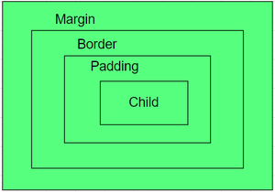
color: The color property sets the background color of the entire container
import 'package:flutter/material.dart'; void main() => runApp(const MyApp()); class MyApp extends StatelessWidget { const MyApp({Key? key}) : super(key: key); @override
Widget build(BuildContext context) {
return MaterialApp( home
: Scaffold(appBar: AppBar(title: const Text("Container example"),
), body: Container(color: Colors.purple,
child: const Text("Hello! i am inside a container!", style: TextStyle(fontSize : 20)),
),), );}}

height and width: By default, a container class takes the space that is required by the child. We can also specify the height and width of the container based on our requirements.
body: Container(
height: 200,
width: double.infinity, color: Colors.purple,
child: const Text("Hello! i am inside a container!", style: TextStyle(fontSize: 20)),
),
margin: The margin is used to create an empty space around the container. Observe the white space around the container. Here EdgeInsets.geometry is used to set the margin .all() indicates that the margin is present in all four directions equally.
import 'package:flutter/material.dart'; void main() => runApp(const MyApp()); class MyApp extends StatelessWidget { const MyApp({Key? key}) : super(key: key); @override
Widget build(BuildContext context) { return MaterialApp(
home: Scaffold( appBar: AppBar(
title: const Text("Container example"),
),
body: Container( height: 200,
width: double.infinity, color: Colors.purple,
margin: const EdgeInsets.all(20),
child: const Text("Hello! i am inside a container!", style: TextStyle(fontSize: 20)),
),),);}}
padding: The padding is used to give space from the border of the container from its children. Observe the space between the border and the text.
body: Container(
height: 200,
width: double.infinity, color: Colors.purple,
margin: const EdgeInsets.all(20), padding: const EdgeInsets.all(30),
child: const Text("Hello! i am inside a container!", style: TextStyle(fontSize: 20)),
),
alignment: The alignment is used to position the child within the container. We can align in different ways: bottom, bottom center, left, right, etc. here the child is aligned to the bottom center.
body: Container(
height: 200,
width: double.infinity, color: Colors.purple,
alignment: Alignment.bottomCenter, margin: const EdgeInsets.all(20), padding: const EdgeInsets.all(30),
child: const Text("Hello! i am inside a container!", style: TextStyle(fontSize: 20)),
),
Decoration: The decoration property is used to decorate the box(e.g. give a border). This paints behind the child. Whereas foreground Decoration paints in front of a child.
body: Container(
height: 200,
width: double.infinity,
//color: Colors.purple, alignment: Alignment.center,
margin: const EdgeInsets.all(20), padding: const EdgeInsets.all(30), decoration: BoxDecoration(
border: Border.all(color: Colors.black, width: 3),
),
child: const Text("Hello! i am inside a container!", style: TextStyle(fontSize: 20)),
),
Transform: This property of the container helps us to rotate the container. We can rotate the container in any axis, here we are rotating in the z-axis.
body: Container(
height: 200,
width: double.infinity, color: Colors.purple,
alignment: Alignment.center,
margin: const EdgeInsets.all(20), padding: const EdgeInsets.all(30), transform: Matrix4.rotationZ(0.1),
child: const Text("Hello! i am inside a container!", style: TextStyle(fontSize: 20)),
),

Row & Column comparison
Column | Row
MultiChild Widget | MultiChild Widget
Align all Children Widgets in a vertical direction | Align all children Widgets in a horizontal direction

the column widget aligns the children’s widget vertical direction. To change the UI, we need to play with CrossAxisAligment & MainAxisAlignment. In the Column widget, MainAxisAligment will be in the vertical direction & CrossAxisAligment in the horizontal direction.

Container(
color: Colors.grey[300], width: double.infinity, height: double.infinity, child: Column(
mainAxisAlignment: MainAxisAlignment.start, crossAxisAlignment: CrossAxisAlignment.start, children: [
Container( height: 50,
width: 50,
color: Colors.red,
),
Container( height: 50,
width: 50,
color: Colors.green,
),
Container( height: 50,
width: 50,
color: Colors.blue,
),
],
),
),

Exploring Row Widget
As said before, the row widget aligns children widget horizontal direction. To change the UI, we need to play with CrossAxisAligment & MainAxisAlignment. In the Row widget, MainAxisAligment will be in the horizontal direction & CrossAxisAligment in the vertical direction.
Container(
color: Colors.grey[300], width: double.infinity, height: double.infinity, child: Row(
mainAxisAlignment: MainAxisAlignment.start, crossAxisAlignment: CrossAxisAlignment.start, children: [
Container( height: 50,
width: 50,
color: Colors.red,
),
Container( height: 50,
width: 50,
color: Colors.green,
),
Container( height: 50,
width: 50,
color: Colors.blue,
),
],
),
),
Image
Image widget is used to display an image in the application. Image widget provides different constructors to load images from multiple sources and they are as follows −
Image − Generic image loader using ImageProvider
Image.asset − Load image from flutter project’s assets Image.file − Load image from system folder
Image.memory − Load image from memory Image.Network − Load image from network

The easiest option to load and display an image in Flutter is by including the image as assets of the application and load it into the widget on demand.
Create a folder, assets in the project folder and place the necessary images.

Specify the assets in the pubspec.yaml as shown below − flutter:
assets:
- assets/smiley.png
Now, load and display the image in the application. Image.asset('assets/smiley.png')
The complete source code of MyHomePage widget of the hello world application and the result is as shown below −.
class MyHomePage extends StatelessWidget {
MyHomePage({Key key, this.title}) : super(key: key); final String title;
@override
Widget build(BuildContext context) { return Scaffold(
appBar: AppBar( title: Text(this.title), ),
body: Center( child: Image.asset("assets/smiley.png")),
);
}
}

Resource : https://api.flutter.dev/flutter/widgets/Container-class.html
Lab Exercise:
You are required to create following UI layouts using widgets like rows, column, container, images, icons.

Lab Task 1:
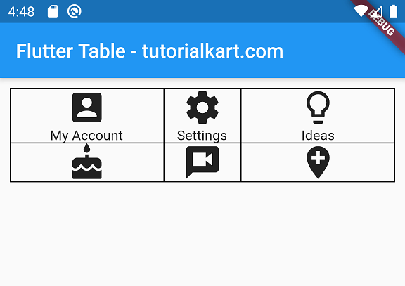
Lab Task 2:
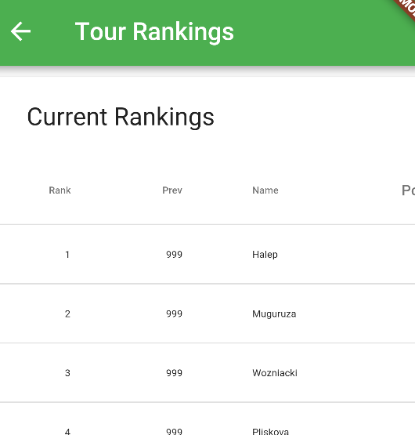

Lab Task 3: Hint[Use nested rows,columns]

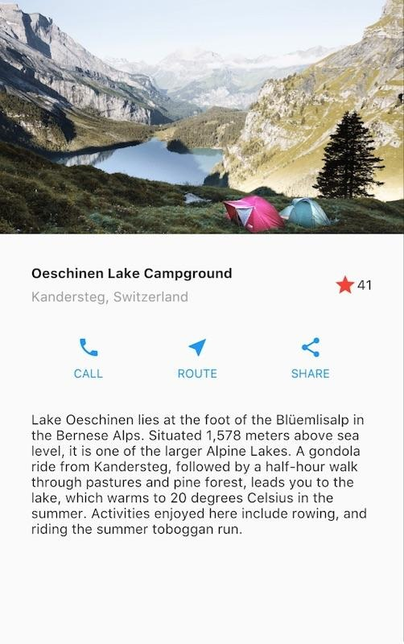

Evaluation criteria
The evaluation criteria for this lab will be based on the completion of the following tasks. Each task is assigned the marks percentage which will be evaluated by the instructor in the lab whether the student has finished the complete/partial task(s).

Table 1: Evaluation of the Lab
Sr. No. | Description | Marks
1 | Task 1 | 10
2 | Task 2 | 10
3 | Task 3 | 10
Further Reading
Books
The slides and reading material can be accessed from the folder of the class instructor available at Moellim.
Outcomes
The outcomes of this lab were:
Students have learnt about basic widget elements in an applicaton.

